**BACKLOG MANAGEMENT SYSTEM**

**A Project Report**

Submitted in partial fulfillment of the

Requirements for the award of degree of

**MASTER OF COMPUTER APPLICATIONS**

**By**

N. NAGA SAIKIRAN

158W1F0034

**Under the Esteemed Guidance of**

**Mr. J. Hari Krishna M.Tech**

**Assistant Professor**



**DEPARTMENT OF COMPUTER APPLICATIONS**

**V.R.SIDDHARTHA ENGINEERING COLLEGE**

***(Autonomous)***

**VIJAYAWADA-520007**

**ANDHRA PRADESH**

**2018**

**V.R.SIDDHARTHA ENGINEERING COLLEGE**

***(Autonomous)***

**KANURU, VIJAYAWADA-520007**

**DEPARTMENT OF COMPUTER APPLICATIONS**



**CERTIFICATE**

This is to certify that the project entitled, **"BACKLOG MANAGEMENT SYSTEM"**, is bonafied work of **N.NAGA SAIKIRAN** bearing Regd.No: (**158W1F0034**) submitted in partial fulfillment of the requirements for the award of degree of **MASTER OF COMPUTER APPLICATIONS** from JNTUK, Kakinada.

**Internal Guide Head of the Department**

**External Examiner**

**ABSTRACT**

Backlog means number of subjects which have not been cleared in exams. i.e. it refers to the number of subjects failed by a student. This system manages the backlog subjects of all students in the college. This system managed by the staff of the department. Staff updates the backlog student details along with course details for example Regulation, Department, Subject codes, Subject names etc.

Backlog of all students can be viewed manually.In the proposed system maintain the backlog subjects and details of all students. This system generates the reports of the students like subject wise, roll number wise & cumulative. When the students clear their backlogs then remove from this system.

There are some advantages to maintain this system likestudents can monitor their backlog subjects, No need to maintain manual reports,all the staff members can view the backlog student’s data based on their requirement and finallystaff can analyze which subjects are frequently failed by students.

**ACKNOWLEDGEMENT**

I, extremely thankful to our project guide **Sri. J.HARI KRISHNA**, Assistant Professor, Department of Computer Applications, VR Siddhartha Engineering College, JNTU, Kakinada for his timely cooperation and valuable suggestions throughout the project. We are indebted to his for the opportunity given to work under his guidance.

I, extremely thankful to **Sri. K.Anji Reddy**, Head of the Department, Department of Computer Applications and **Dr.A.V.Ratna Prasad, Principal,** **V.R.Siddhartha Engineering College, Vijayawada** for providing good environment and better infrastructure facilities.

My sincere thanks to all the teaching and non-teaching staff of Department of Computer Applications for their support throughout my project work.

Finally I am very much indebted to my family for their moral support and encouragement to achieve higher goals.

**DECLARATION**

I N.NAGA SAIKIRAN (158W1F0034) hereby declare the project report titled “**BACKLOG MANAGEMENT SYSTEM”** under esteemed supervision of Sri. J.HARI KRISHNAis submitted in partial fulfillment of the requirements for the award of the degree of **Master of Computer Applications (MCA)**.

This is a record of work carried out by me and the results embodied in this project have not been reproduced or copied from any source. The results embodied in this project report have not been submitted to any other Institute or University for the award of any other degree or diploma.

N.NAGA SAIKIRAN

158W1F0034

MCA, MCA Department.,

VR Siddhartha Engineering College

Kanuru-520007

**List of Figures**

|  |  |  |  |
| --- | --- | --- | --- |
| **S.No** | **Fig. No.** | **Fig. Name** | **Page No.** |
| 1 | Figure 3.5 | ER Diagram | 12 |
| 2 | Figure 3.6 | Use Case Diagram | 13 |
| 3 | Figure 3.7 | Class Diagram | 14 |
| 4 | Figure 3.8 | Activity Diagram | 15 |
| 5 | Figure 3.9 | Sequence Diagram | 16 |
| 6 | Figure 5.1 | Home screen | 39 |
| 7 | Figure 5.2 | About Us | 39 |
| 8 | Figure 5.3 | Contact Us | 40 |
| 9 | Figure 5.4 | Login | 40 |
| 10 | Figure 5.5 | Admin Home page | 41 |
| 11 | Figure 5.6 | Regulation Add page | 41 |
| 12 | Figure 5.7 | Regulation View page | 42 |
| 13 | Figure 5.8 | Regulation Delete page | 42 |
| 14 | Figure 5.9 | Subjects Add page | 43 |
| 15 | Figure 5.10 | Subjects View page | 43 |
| 16 | Figure 5.11 | Backlog Students Add page | 44 |
| 17 | Figure 5.12 | Backlogs Students View page | 44 |
| 18 | Figure 5.13 | Student Wise Backlogs List | 45 |
| 19 | Figure 5.14 | Subject Wise Backlogs List | 45 |
| 20 | Figure 5.15 | Department Wise Backlogs List | 46 |
| 21 | Figure 5.16 | View Total Backlogs List | 46 |
| 22 | Figure 5.17 | Faculty Home page | 47 |
| 23 | Figure 5.18 | Student Home page | 47 |

**List of Tables**

|  |  |  |  |
| --- | --- | --- | --- |
| **S.No** | **Table No.** | **Table Name** | **Page No.** |
| 1 | Table 2.1 | Hardware Requirements | 4 |
| 2 | Table3.1 | Description of LOGIN | 10 |
| 3 | Table3.2 | Description of REGULATION | 10 |
| 4 | Table3.3 | Description of SUBJECTS | 10 |
| 5 | Table3.4 | Description of BACKLOGS | 11 |
| 6 | Table4.1 | Unit Test Case | 37 |
| 7 | Table4.2 | Integration Test Case | 38 |

**INDEX**

**Content Page No.**

**Abstract I**

**Acknowledgement II**

**Declaration III**

**List of Figures IV**

**List of Tables V**

**Chapter 1: Introduction** 01

* 1. **Background** 01
  2. **Objectives** 01
  3. **Purpose and Scope**  02

1.2.1**Purpose** 02

1.2.2**Scope** 02

**Chapter 2: System Analysis** 03

* 1. **Existing System**  03
  2. **Proposed System** 03
  3. **Requirement Analysis** 03
  4. **Hardware Requirements** 04
  5. **Software Requirements** 04
  6. **Justification of selection of Technology** 05

**Chapter 3: System Design** 09

* 1. **Module Division** 09
  2. **Data Dictionary** 10
  3. **ER Diagrams** 11
  4. **DFD/UML Diagrams** 13

3.4.1 **Use case Diagram** 13

3.4.2 **Class Diagram** 14

3.4.3 **Activity Diagram** 15

3.4.4 **Sequence Diagram** 16

**Chapter 4: Implementation and Testing** 17

* 1. **Code** 17
  2. **Testing Approach** 37

4.2.1**Unit Testing** 37

4.2.2 **Integration Testing** 38

**Chapter 5: Results and Discussions (Output Screens)** 39

**Chapter 6: Conclusion and Future Work** 48

**Chapter 7: References** 49

**Chapter 1**

**Introduction**

* 1. **Background**

Background of the problem is that all the records are maintained manually at the time of results released. In this case there may be a chance to mislead students by changing their record values. So that valuable student data/information can be stored for a longer period of time with easy accessing and manipulation can be done. Basically the project describes how to manage for good performance and better services to the users.

* 1. **Objectives**

The main objective of the project is to provide the Backlogs to the student in a simple way. This project is useful for students and educational institutions for getting the Backlogs in simple manner. By a result analyzer with subject status is an application tool for displaying the Backlogs in secure way.

The system is intended for the students and Faculty. And the privileges that are provided to student are to read and execute his/her result by providing user name and password for secure login. And the guest user has the privilege only to read.

The whole system analyzer will be under the control of the administrator and the admin has the full privileges to read, write and execute the Backlogs. And admin gives the privileges to the Faculty and student and the guest user to access the reports.

* Provides the searching facilities based on various factors such as subject wise backlogs, student wise backlogs, department wise backlogs and Total backlogs.
* Backlog Management System also manages Regulation details, department details, subject details and academic year details.
* It tracks the information of students, regulation, department, semester and academic year.
* Adding, viewing, Editing, Deleting operation of records are improved.

**1.3 Purpose and Scope**

**1.3.1 Purpose**

The purpose of this system is to maintain the details of the Backlogs of all students in the college. This system managed by the staff of the department. Staff updates the backlog student details along with course details for example Regulation, Department, Subject codes, Subject names etc. Backlog of all students can be viewed manually. This system generates the reports of the students like subject wise, roll number wise & cumulative. In this case faculty and students can check the details whenever they needed.

**1.3.2 Scope**.

This application will manage the information about various students enrolled in this course in different years, the subjects offered during different semesters of the department the backlogs obtained by the various students in various subjects in different semesters. The application will greatly simplify and store the details. Retrieve the particular student information accurately and efficiently

**Chapter 2**

**System Analysis**

**2.1 Existing System**

In this system backlogs of all students can be viewed manually at the time of results released. In this case there may be a chance to mislead students by changing their record values.

**2.2 Proposed System**

In this proposed system maintain the backlog subjects and details of all students. This system generates the reports of the students like subject wise, roll number wise & cumulative. When the students clear their backlogs then remove from this system.

**2.3 Requirement Analysis**

The project is to provide the Backlogs to the student in a simple way. This project is useful for students and educational institutions for getting the Backlogs in simple manner. By a result analyzer with subject status is an application tool for displaying the Backlogs in secure way. So that valuable student data/information can be stored for a longer period of time with easy accessing and manipulation can be done. Basically the project describes how to manage for good performance and better services to the users.

* System needs store information about new entry of information.
* System needs to maintain the quality records.
* System need to keep the record of progress.
* System need to add, update, delete the records.
* System also needs a search based on user requirements.
* It also needs a security system to prevent the data.

**2.4 Hardware Requirements**

Minimum hardware requirements for all windows versions

|  |  |  |
| --- | --- | --- |
| **Architecture** | 32-bit | 64-bit |
| **Processor** | 1 GHz x86 processor | 1 GHz x64 processor |
| **Memory (RAM)** | 256MB | 512MB |
| **HDD free space** | 16GB Free disk space | 20GB Free disk space |

**Table 2.1:** Hardware Requirements

**2.5 Software Requirements**

**Front end:** HTML, CSS, JavaScript, Bootstrap

* HTML: HTML is used to create web documents.
* CSS: (Cascading Style Sheets) Create attractive Layout
* JavaScript: it is a programming language, commonly use with web browsers.
* Bootstrap: Bootstrap is a framework to help you design websites faster and easier.

**Back end:** PHP, MySQL

* PHP: Hypertext Preprocessor (PHP) is a technology that allows software developers to create dynamically generated web pages, in HTML, XML, or other document types, as per client request. PHP is open source software.
* MySQL: MySQL is a database, widely used for accessing querying, updating, and managing data in databases

**Server requirement (any one)**

* XAMP Server
* WAMP Server

**2.6 Justification of Platform**

There are several technologies to do this project

**Why PHP?**

PHP stands for Hypertext Preprocessor and is a server-side programming language. There are many reasons to use PHP for server side programming, firstly it is a free language with no licensing fees so the cost of using it is minimal.

A good benefit of using PHP is that it can interact with many different database languages including MySQL. We work with MySQL at Bluelinemedia since this is also a free language so it makes sense to use PHP. Both PHP and MySQL are compatible with an Apache server which is also free to license. PHP can also run on Windows, Linux and Unix servers.

Due to all these languages being free it is cheap and easy to setup and create a website using PHP. PHP also has very good online documentation with a good [framework](http://www.bluelinemedia.co.uk/blog/shouldyouuseframeworkswhencoding) of functions in place. This makes the language relatively easy to learn and very well supported online. Due to PHP being so accessible and cheap to setup there are a lot of people who know how to use the language which makes finding new employees proficient in this language less challenging.

**Why MySQL?**

MySQL is a free, open-source database management system (DBMS for short). A DBMS is a system that manages databases and connects them to software. For example, a MySQL database can be used to run a website, to run the database of an ERP or any other software. MySQL is a powerful that has been around for years. It is very stable and has a big community that helps to maintain, debug and upgrade in day to day life.  
MySQL might not be as popular for larger systems that will mostly run on Microsoft SQL Server or Oracle. These proprietary DBMS are more scalable, have more resources available on the market and have more advanced features that MySQL.

**Why Apache?**

Apache is the most widely used web server software. Developed and maintained by Apache Software Foundation, Apache is an open source software available for free. It runs on 67% of all webservers in the world. It is fast, reliable, and secure. It can be highly customized to meet the needs of many different environments by using extensions and modules. Most WordPress hosting providers use Apache as their web server software. However, WordPress can run on other web server software as well.

So basically a web server is the software that receives your request to access a web page. It runs a few security checks on your HTTP request and takes you to the web page. Depending on the page you have requested, the page may ask the server to run a few extra modules while generating the document to serve you. It then serves you the document you requested.

**Why HTML?**

**1. HTML is easy to use and understand:**

Almost anyone in the web development business would know HTML – be it a freelancer or a large agency. If at any point in time you need to hire the services of a different web design firm or professional for making changes or updates to your website, it would be relatively easy to find cost-effective and affordable solution providers who can make the changes you need to your website.

**2. All browsers support HTML:**

Almost – if not all – browsers support HTML. Certainly more browsers support HTML than any other web programming language. As a result, when you build a website using HTML, it would show up on most browsers around the world, as long as the programmer takes care to optimize the website for the most commonly used browsers. Optimizing an HTML based website for browser compatibility is neither difficult nor complex

**3. Most development tools support HTML:**

Whether it is FrontPage, Dreamweaver or any other programming tool, there are more web development tools that allow you to create HTML based websites, than any other web programming language.

**Why CSS?**

Cascading Style Sheets or CSS are an important way to control how your Web pages look. CSS can control the fonts, text, colors, backgrounds, margins, layout and variations in display for different devices and screen sizes.

**Internal style sheets:** These are styles that are placed in the <head> of the HTML document. These styles affect only the document they are in, and cannot be referenced by any other Web document. They allow you to test the styles in the context of the entire site without breaking any page but the one you are testing. This is especially useful when you're working with things like email where you have only one HTML file.

**External Style Sheets:** The external style sheet is generally used when you want to make changes on multiple pages. It is ideal for this condition because it facilitates you to change the look of the entire web site by changing just one file. It uses the <link> tag on every pages and the <link> tag should be put inside the head section.

**Why JavaScript?**

As the system involves submission of user filled forms and hence require a client-side scripting for validation purposes. Java-script is worth for validation purposes and many recent browsers support java-script. It was originally implemented as part of web browsers so that client-side scripts could interact with the user, control the browser, communicate asynchronously, and alter the document content that was displayed.  Its syntax was influenced by the language C. JavaScript copies many names and naming conventions from Java, but the two languages are otherwise unrelated and have very different semantics.

* Enhances functionality and appearance
* Client-side scripting
* Makes page more dynamic and interactive
* Foundation for complex server-side scripting
* Program development
* Program control

**Why BOOTSTRAP?**

Bootstrap has become an increasingly popular front-end development framework. Using Bootstrap is the speed of development. If you’re looking to push out a new website or application quickly, you should definitely consider using Bootstrap.

Bootstrap requires [JQuery](https://jquery.com/) to function. JQuery is an extremely popular and widely used JavaScript library that both simplifies and adds cross browser compatibility to JavaScript. Rather than coding from scratch, Bootstrap enables you to utilize readymade blocks of code to help you get started. Combine that with cross-browser compatibility and CSS-Less functionality, many hours of coding can be saved. To achieve the fastest route possible, you can also purchase ready-made [Bootstrap themes](http://bootstrapbay.com/) and modify them to suit your needs Creating mobile ready websites is a breeze with Bootstrap thanks to the fluid grid layout that dynamically adjusts to the proper screen resolution resent repetition between projects Utilize responsive design to allow your website to adapt to various screen sizes – mobile, desktop, and everything in between, add consistency to design and code between projects and between developers. Quickly and easily prototype new designs. Ensure cross-browser compatibility.

**Chapter 3**

**System Design**

**3.1 Module Division**

This system contains two modules namely:

3.1.1. Admin Module

3.1.2. User Module

**Description of Modules:**

In software engineering a module is a portion of a project that carries out a specific function and may be used alone or combined with other modules of the same project. Here we present detailed description of each and every module highlighting its features.

**3.1.1. Admin Module**

Admin perform the basic tasks of Add/View/Delete Regulation, Subjects and Backlogs of students. And generate the reports of student wise, subject wise, department wise and cumulative.

**3.1.2. User Module**

User Faculty can search different type of reports such as student wise, subject wise, department wise and cumulative. User Student can search their Backlogs using valid roll number.

**3.2 Data Dictionary**

|  |  |  |  |  |
| --- | --- | --- | --- | --- |
| **RELATION NAME** | **COLUMN NAME** | **DATA TYPE** | **SIZE** | **CONSTRAINT** |
| LOGIN | USERNAME | VARCHAR | 50 | NOT NULL |
| LOGIN | PASSWORD | VARCHAR | 50 | NOT NULL |

**Table 3.1:** Description of LOGIN

|  |  |  |  |  |
| --- | --- | --- | --- | --- |
| **RELATION NAME** | **COLUMN NAME** | **DATA TYPE** | **SIZE** | **CONSTRAINT** |
| REGULATION | REGULATION | VARCHAR | 30 | NOT NULL |

**Table 3.2:** Description of REGULATION

|  |  |  |  |  |
| --- | --- | --- | --- | --- |
| **RELATION NAME** | **COLUMN NAME** | **DATA TYPE** | **SIZE** | **CONSTRAINT** |
| SUBJECTS | DEPTNAME | VARCHAR | 50 | NOT NULL |
| SUBJECTS | SUBJECTCODE | VARCHAR | 50 | PRIMARY KEY |
| SUBJECTS | SUBJECTNAME | VARCHAR | 50 | NOT NULL |
| SUBJECTS | SEMESTER | NUMBER | 10 | NOT NULL |
| SUBJECTS | REGULATION | VARCHAR | 50 | NOT NULL |

**Table 3.3:** Description of SUBJECTS

|  |  |  |  |  |
| --- | --- | --- | --- | --- |
| **RELATION NAME** | **COLUMN NAME** | **DATA TYPE** | **SIZE** | **CONSTRAINT** |
| BACKLOGS | ROLLNO | VARCHAR | 50 | PRIMARY KEY |
| BACKLOGS | NAME | VARCHAR | 50 | NOT NULL |
| BACKLOGS | REGULATION | VARCHAR | 50 | NOT NULL |
| BACKLOGS | DEPTNAME | VARCHAR | 50 | NOT NULL |
| BACKLOGS | SEMESTER | NUMBER | 10 | NOT NULL |
| BACKLOGS | SUBJECTCODE | VARCHAR | 50 | NOT NULL |
| BACKLOGS | SUBJECTNAME | VARCHAR | 50 | NOT NULL |
| BACKLOGS | ACADEMICYEAR | DATE | 20 | NOT NULL |

**Table 3.4:** Description of BACKLOGS

**3.3 E-R Diagrams**

This type of diagramming is used to show relationships between objects in a system. A relational database can have several different types of relationships, depending on the needs that the database is to fulfill.

## Entity

Entities are represented by means of rectangles. Rectangles are named with the entity set they represent

**Attributes**

Attributes are the properties of entities. Attributes are represented by means of ellipses. Every ellipse represents one attribute and is directly connected to its entity (rectangle).

**Constraints**

Every relation has some conditions that must hold for it to be a valid relation. These conditions are called Relational Integrity Constraints. There are three main integrity constraints

* Key constraints
* Domain constraints
* Referential integrity constraints

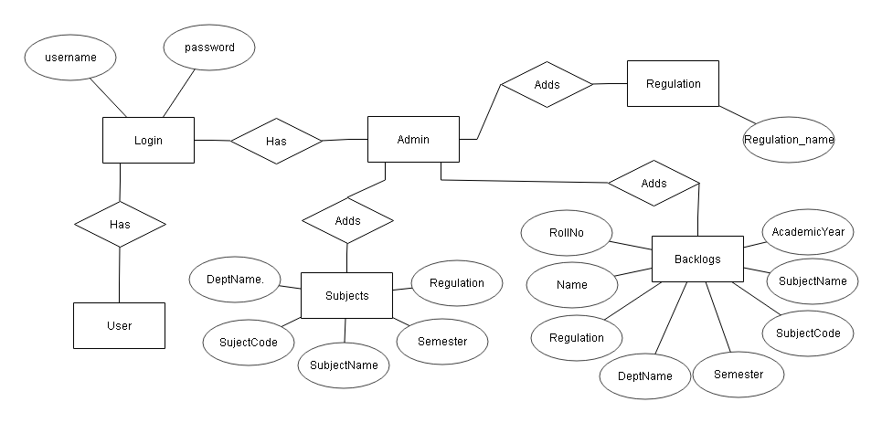

**Figure 3.5:** ER Diagram

**3.4 UML Diagrams**

**3.4.1 Use Case Diagram:**

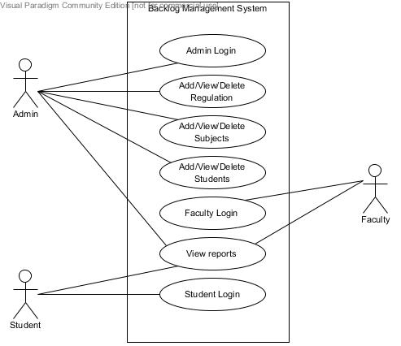

**Figure 3.6:** Use Case Diagram

**Description:**

The above Fig use case diagram contains three users namely Admin, Faculty, Student Admin perform the basic tasks of Add/View/Delete Regulation, Subjects and Backlogs of students. And generate the reports of student wise, subject wise, department wise and cumulative. User Student can search their Backlogs using valid roll number

* + 1. **Class Diagram**

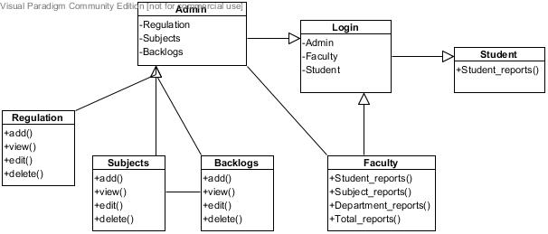

**Figure 3.7:** Class Diagram

**Description:**

The above Fig Class diagram is a static diagram. It represents the static view of an application. Class diagram is not only used for visualizing, describing, and documenting different aspects of a system but also for constructing executable code of the software application.

The purpose of class diagram is to model the static view of an application. Class diagrams are the only diagrams which can be directly mapped with object-oriented languages and thus widely used at the time of construction.

* + 1. **Activity Diagram**

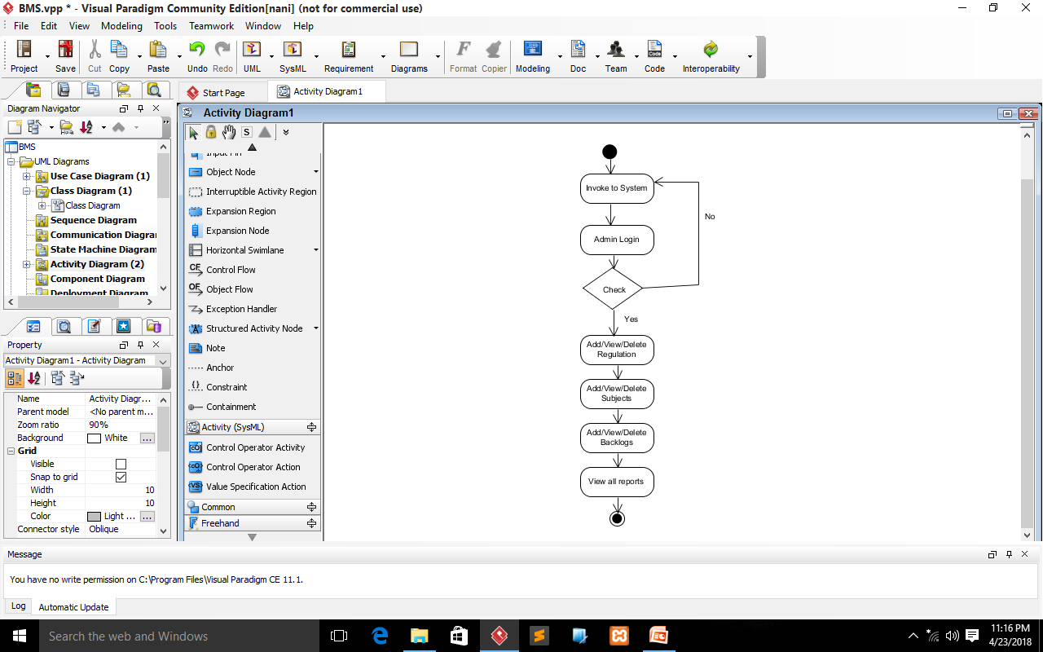

**Figure 3.8:** Activity Diagram

**Description:**

The above Fig Activity diagram is basically a flowchart to represent the flow from one activity to another activity. The activity can be described as an operation of the system.

The control flow is drawn from one operation to another. This flow can be sequential, branched, or concurrent. Activity diagrams deal with all type of flow control by using different elements such as fork, join, etc

* + 1. **Sequence Diagram**

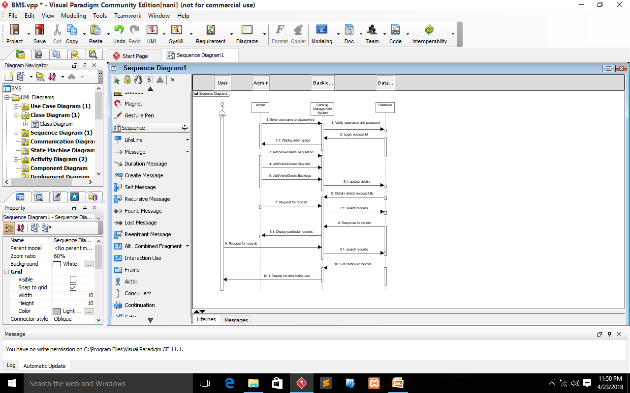

**Figure 3.9:** Sequence Diagram

**Description:**

The above Fig sequence diagrams are used to represent or model the flow of messages, events and actions between the objects or components of a system. Time is represented in the vertical direction showing the sequence of interactions of the header elements, which are displayed horizontally at the top of the diagram.

**Chapter 4**

**Implementation and Testing**

**4.1 Code**

**index.php**

<!DOCTYPE html>

<html lang="en">

<head>

<meta charset="utf-8">

<meta name="viewport" content="width=device-width, initial-scale=1.0">

<meta name="description" content="">

<meta name="author" content="">

<title>BackLog Managment System</title>

<link href="css/bootstrap.min.css" rel="stylesheet">

<link href="css/font-awesome.min.css" rel="stylesheet">

<link href="css/animate.min.css" rel="stylesheet">

<link href="css/prettyPhoto.css" rel="stylesheet">

<link href="css/main.css" rel="stylesheet">

<link href="css/responsive.css" rel="stylesheet">

<script src="js/html5shiv.js"></script>

<script src="js/respond.min.js"></script>

<link rel="shortcut icon" href="images/ico/favicon.ico">

<link rel="apple-touch-icon-precomposed" sizes="144x144" href="images/ico/apple-touch-icon-144-precomposed.png">

<link rel="apple-touch-icon-precomposed" sizes="114x114" href="images/ico/apple-touch-icon-114-precomposed.png">

<link rel="apple-touch-icon-precomposed" sizes="72x72" href="images/ico/apple-touch-icon-72-precomposed.png">

<link rel="apple-touch-icon-precomposed" href="images/ico/apple-touch-icon-57-precomposed.png">

</head>

<body class="homepage">

<header id="header">

<div class="top-bar">

<div class="container">

</div></div></div>

</div><!--/.container-->

</div><!--/.top-bar-->

<nav class="navbar navbar-inverse" role="banner">

<div class="container">

<div class="navbar-header">

<button type="button" class="navbar-toggle" data-toggle="collapse" data-target=".navbar-collapse">

<span class="sr-only">Toggle navigation</span>

<span class="icon-bar"></span>

<span class="icon-bar"></span>

<span class="icon-bar"></span>

</button>

<a class="navbar-brand" href="index.php">BackLog Management System</a>

</div>

<div class="collapse navbar-collapse navbar-right">

<ul class="nav navbar-nav">

<li class="active"><a href="index.php">Home</a></li>

<li><a href="AboutUs.php">About Us</a></li>

<li><a href="Login.php">Login</a></li>

<li><a href="ContactUs.php">Contact</a></li>

</ul></div>

</div><!--/.container-->

</nav><!--/nav-->

</header><!--/header-->

<section>

<div class="container">

<div class="center wow fadeInDown">

<h2>BackLog Management System</h2>

<img src="images/home.jpg" width="750px" height="400px"/><br/>

<p class="lead">

Backlog means number of subjects which have not been cleared in exams.</br>

i.e it refers to the number of subjects failed by a student.</br>

This system manages the backlog subjects of all students in the college.</br>

This system managed by the staff of the department.</br>

Staff updates the backlog student details along with course details

</p></div>

</div><!--/.services-->

</div><!--/.row-->

</div><!--/.container-->

</section><!--/#feature-->

<script src="js/jquery.js"></script>

<script src="js/bootstrap.min.js"></script>

<script src="js/jquery.prettyPhoto.js"></script>

<script src="js/jquery.isotope.min.js"></script>

<script src="js/main.js"></script>

<script src="js/wow.min.js"></script>

</body>

</html>

**Login.php**

<?php

session_start();

if(isset($_POST['login']))

{

$uname = $_POST['uname'];

$pass = $_POST['pass'];

$ltype=$_POST['logintype'];

$_SESSION['user']=$uname;

$_SESSION['pass']=$pass;

if($uname!="" && $pass!="")

{

if($uname=="admin" && $pass=="admin" && $ltype=="Admin")

{

echo "<script>document.location='AdminHome.php'</script>";

}

else if($uname=="student" && $pass=="student" && $ltype=="Student")

{

echo "<script>document.location='StudentHome.php'</script>";

}

else if($uname=="faculty" && $pass=="faculty" && $ltype=="Faculty")

{

echo "<script>document.location='FacultyHome.php'</script>";

}

else

{

echo '<script>alert("Invalid username and password......")</script>';

}}

else

{

echo '<script>alert("Please Fill all Details.....")</script>';

}}

?>

<!DOCTYPE html>

<html lang="en">

<head>

<meta charset="utf-8">

<meta name="viewport" content="width=device-width, initial-scale=1.0">

<meta name="description" content="">

<meta name="author" content="">

<title>BackLog Managment System</title>

<link href="css/bootstrap.min.css" rel="stylesheet">

<link href="css/font-awesome.min.css" rel="stylesheet">

<link href="css/animate.min.css" rel="stylesheet">

<link href="css/prettyPhoto.css" rel="stylesheet">

<link href="css/main.css" rel="stylesheet">

<link href="css/responsive.css" rel="stylesheet">

<script src="js/html5shiv.js"></script>

<script src="js/respond.min.js"></script>

<link rel="shortcut icon" href="images/ico/favicon.ico">

<link rel="apple-touch-icon-precomposed" sizes="144x144" href="images/ico/apple-touch-icon-144-precomposed.png">

<link rel="apple-touch-icon-precomposed" sizes="114x114" href="images/ico/apple-touch-icon-114-precomposed.png">

<link rel="apple-touch-icon-precomposed" sizes="72x72" href="images/ico/apple-touch-icon-72-precomposed.png">

<link rel="apple-touch-icon-precomposed" href="images/ico/apple-touch-icon-57-precomposed.png">

</head>

<body class="homepage">

<header id="header">

<div class="top-bar">

<div class="container">

</div></div>

</div></div><!--/.container-->

</div><!--/.top-bar-->

<nav class="navbar navbar-inverse" role="banner">

<div class="container">

<div class="navbar-header">

<button type="button" class="navbar-toggle" data-toggle="collapse" data-target=".navbar-collapse">

<span class="sr-only">Toggle navigation</span>

<span class="icon-bar"></span>

<span class="icon-bar"></span>

<span class="icon-bar"></span></button>

<a class="navbar-brand" href="index.php">BackLog Management System</a>

</div>

<div class="collapse navbar-collapse navbar-right">

<ul class="nav navbar-nav">

<li class="active"><a href="index.php">Home</a></li>

<li><a href="AboutUs.php">About Us</a></li>

<li><a href="Login.php">Login</a></li>

<li><a href="ContactUs.php">Contact</a></li>

</ul></div>

</div><!--/.container-->

</nav><!--/nav-->

</header><!--/header-->

<section>

<section id="contact-page">

<div class="container">

<div class="center">

<h2>Login</h2>

</div>

<div class="row contact-wrap ">

<div class="status alert alert-success" style="display: none"></div>

<form class="contact-form" method="post" enctype="multipart/form-data">

<div class="col-sm-5">

<div class="form-group">

<label><b>User ID *</b></label>

<input type="text" name="uname" class="form-control" required="required">

</div>

<div class="form-group">

<label><b>Password *</b></label>

<input type="password" name="pass" class="form-control" required="required">

</div>

<div class="form-group">

<label><b>Login Type *</b></label>

<select name="logintype" class="form-control">

<option>-- Select --</option>

<option>Admin</option>

<option>Faculty</option>

<option>Student</option>

</select>

</div>

<div class="form-group">

<center><button type="submit" name="login" class="btn btn-primary btn-lg" required="required">Login</button></center>

</div></div>

</form>

<img src="images/login.jpg" width="450px" height="250px" align="right"/><br/>

</div><!--/.row-->

</div><!--/.container-->

</section><!--/#contact-page-->

</section>

<script src="js/jquery.js"></script>

<script src="js/bootstrap.min.js"></script>

<script src="js/jquery.prettyPhoto.js"></script>

<script src="js/jquery.isotope.min.js"></script>

<script src="js/main.js"></script>

<script src="js/wow.min.js"></script>

</body>

</html>

**Subjects_View.php**

<!DOCTYPE html>

<html lang="en">

<head>

<meta charset="utf-8">

<meta name="viewport" content="width=device-width, initial-scale=1.0">

<meta name="description" content="">

<meta name="author" content="">

<title>BackLog Managment System</title>

<link href="css/bootstrap.min.css" rel="stylesheet">

<link href="css/font-awesome.min.css" rel="stylesheet">

<link href="css/animate.min.css" rel="stylesheet">

<link href="css/prettyPhoto.css" rel="stylesheet">

<link href="css/main.css" rel="stylesheet">

<link href="css/responsive.css" rel="stylesheet">

<script src="js/html5shiv.js"></script>

<script src="js/respond.min.js"></script>

<link rel="shortcut icon" href="images/ico/favicon.ico">

<link rel="apple-touch-icon-precomposed" sizes="144x144" href="images/ico/apple-touch-icon-144-precomposed.png">

<link rel="apple-touch-icon-precomposed" sizes="114x114" href="images/ico/apple-touch-icon-114-precomposed.png">

<link rel="apple-touch-icon-precomposed" sizes="72x72" href="images/ico/apple-touch-icon-72-precomposed.png">

<link rel="apple-touch-icon-precomposed" href="images/ico/apple-touch-icon-57-precomposed.png">

</head><!--/head-->

<body class="homepage">

<header id="header">

<div class="top-bar">

<div class="container">

</div></div>

</div></div><!--/.container-->

</div><!--/.top-bar-->

<nav class="navbar navbar-inverse" role="banner">

<div class="container">

<div class="navbar-header">

<button type="button" class="navbar-toggle" data-toggle="collapse" data-target=".navbar-collapse">

<span class="sr-only">Toggle navigation</span>

<span class="icon-bar"></span>

<span class="icon-bar"></span>

<span class="icon-bar"></span>

</button><a class="navbar-brand" href="">BackLog Management System</a>

</div>

<div class="collapse navbar-collapse navbar-right">

<ul class="nav navbar-nav">

<li><a href="AdminHome.php">Home</a></li>

<li class="dropdown">

<a href="#" class="dropdown-toggle" data-toggle="dropdown">Regulation <i class="fa fa-angle-down"></i></a>

<ul class="dropdown-menu">

<li><a href="Regulation_ADD.php">ADD</a></li>

<li><a href="Regulation_View.php">View / Delete</a></li>

</ul></li>

<li class="dropdown">

<a href="#" class="dropdown-toggle" data-toggle="dropdown">Subjects <i class="fa fa-angle-down"></i></a>

<ul class="dropdown-menu">

<li><a href="Subjects_ADD.php">ADD</a></li>

<li><a href="Subjects_View.php">View / Delete</a></li>

</ul></li>

<li class="dropdown">

<a href="#" class="dropdown-toggle" data-toggle="dropdown">Backlogs <i class="fa fa-angle-down"></i></a>

<ul class="dropdown-menu">

<li><a href="Backlogs_ADD.php">ADD</a></li>

<li><a href="Backlogs_View.php">View / Delete</a></li>

</ul></li>

<li class="dropdown">

<a href="#" class="dropdown-toggle" data-toggle="dropdown">Reports <i class="fa fa-angle-down"></i></a>

<ul class="dropdown-menu">

<li><a href="Admin_Student_BackLog.php">Student Wise BackLogs</a></li>

<li><a href="Admin_Subject_BackLog.php">Subject Wise BackLogs</a></li>

<li><a href="Admin_Department_BackLog.php">Department Wise BackLogs</a></li>

<li><a href="Admin_View_BackLogs.php">Total BackLogs</a></li>

</ul></li>

<li><a href="Login.php">Logout</a></li>

</ul></div>

</div><!--/.container-->

</nav><!--/nav-->

</header><!--/header-->

<section>

<div class="container">

<div class="center wow fadeInDown">

<p class="lead">

<h2>View Subjects</h2>

</p></div>

<div class="row contact-wrap ">

<div class="status alert alert-success" style="display: none"></div>

<form class="contact-form" method="POST" enctype="multipart/form-data">

<div class="col-sm-3">

<div class="form-group">

<label>Regulation *</label>

<select name="Regulation" class="form-control">

<option>-- Select Regulation --</option>

<?php include("dropdown.php"); ?>

</select></div>

<div class="form-group">

<label>Department *</label>

<select name="deptname" class="form-control">

<option value="None">-- Select Department --</option>

<option value="MCA">MCA</option>

<option value="MBA">MBA</option>

</select></div>

<div class="form-group">

<label>Semester *</label>

<select name="semester" class="form-control">

<option value="None">-- Select Semester --</option>

<option value="1">1</option>

<option value="2">2</option>

<option value="3">3</option>

<option value="4">4</option>

<option value="5">5</option>

<option value="6">6</option>

</select></div>

<div class="form-group">

<button type="submit" name="submit" class="btn btn-primary btn-lg" required="required">Search</button>

</div></div>

<!--Next Coloumn -->

<div class="col-sm-7">

<div class="form-group">

<table class="table">

<tr>

<td> <label>Subject Code </label> </td>

<td> <label>Subject Name </label> </td>

</tr>

<?php

$connection=mysql_connect("localhost","root","");

mysql_select_db("BMS",$connection);

if(isset($_POST['submit'])){

$Deptname = $_POST['deptname'];

$Semster = $_POST['semester'];

$Regulation=$_POST['Regulation'];

$query=mysql_query("select * from subjects where DeptName='$Deptname' and Semester='$Semster' and Regulation='$Regulation'");

$count = mysql_num_rows($query);

if($count > 0){

while($display=mysql_fetch_array($query)){

echo "<tr>";

echo "<td>" . $display['SujectCode'] . "</td>";

echo "<td>" . $display['SubjectName'] . "</td>";

echo "<td> <ahref=delete_subjects.php?DeptName=".$Deptname."&Semester=".$Semster."&Regulation=".$Regulation."&SujectCode=".$display['SujectCode']."&SubjectName=".$display['SubjectName'].">Delete</a> </td>";

echo "</tr>";}

}

else{

echo "No Data";

}}

mysql_close();

?>

</table>

</div></div>

</form></div><!--/.row-->

</div><!--/.row-->

</div><!--/.container-->

</section><!--/#feature-->

<script src="js/jquery.js"></script>

<script src="js/bootstrap.min.js"></script>

<script src="js/jquery.prettyPhoto.js"></script>

<script src="js/jquery.isotope.min.js"></script>

<script src="js/main.js"></script>

<script src="js/wow.min.js"></script>

</body>

</html>

**Backlogs_ADD.php**

<!DOCTYPE html>

<html lang="en">

<head>

<meta charset="utf-8">

<meta name="viewport" content="width=device-width, initial-scale=1.0">

<meta name="description" content="">

<meta name="author" content="">

<title>BackLog Managment System</title>

<link href="css/bootstrap.min.css" rel="stylesheet">

<link href="css/font-awesome.min.css" rel="stylesheet">

<link href="css/animate.min.css" rel="stylesheet">

<link href="css/prettyPhoto.css" rel="stylesheet">

<link href="css/main.css" rel="stylesheet">

<link href="css/responsive.css" rel="stylesheet">

<script src="js/html5shiv.js"></script>

<script src="js/respond.min.js"></script>

<link rel="shortcut icon" href="images/ico/favicon.ico">

<link rel="apple-touch-icon-precomposed" sizes="144x144" href="images/ico/apple-touch-icon-144-precomposed.png">

<link rel="apple-touch-icon-precomposed" sizes="114x114" href="images/ico/apple-touch-icon-114-precomposed.png">

<link rel="apple-touch-icon-precomposed" sizes="72x72" href="images/ico/apple-touch-icon-72-precomposed.png">

<link rel="apple-touch-icon-precomposed" href="images/ico/apple-touch-icon-57-precomposed.png">

<script src="https://code.jquery.com/jquery-1.12.4.min.js"></script>

<script type="text/javascript">

$(document).ready(function(){

$(".add-row").click(function(){

var RollNo = $("#rRollNo").val();

var Name = $("#rName").val();

var markup = "<tr><td><input type='checkbox' RollNo='record'></td><td><input type='text' name='RollNo[]' readonly value='"+RollNo+"' placeholder='Enter Subject Code' ><td><input type='text' name='Name[]' readonly value='"+Name+"' placeholder='Enter Subject Name' ></td></tr>";

$("table tbody").append(markup);

$('#rRollNo').val('');

$('#rName').val('');

});

$(".delete-row").click(function(){

$("table tbody").find('input[RollNo="record"]').each(function(){

if($(this).is(":checked")){

$(this).parents("tr").remove();

}});

});});

</script>

</head><!--/head-->

<body class="homepage">

<header id="header">

<div class="top-bar">

<div class="container">

</div></div>

</div></div><!--/.container-->

</div><!--/.top-bar-->

<nav class="navbar navbar-inverse" role="banner">

<div class="container">

<div class="navbar-header">

<button type="button" class="navbar-toggle" data-toggle="collapse" data-target=".navbar-collapse">

<span class="sr-only">Toggle navigation</span>

<span class="icon-bar"></span>

<span class="icon-bar"></span>

<span class="icon-bar"></span>

</button><a class="navbar-brand" href="">BackLog Management System</a>

</div>

<div class="collapse navbar-collapse navbar-right">

<ul class="nav navbar-nav">

<li><a href="AdminHome.php">Home</a></li>

<li class="dropdown">

<a href="#" class="dropdown-toggle" data-toggle="dropdown">Regulation <i class="fa fa-angle-down"></i></a>

<ul class="dropdown-menu">

<li><a href="Regulation_ADD.php">ADD</a></li>

<li><a href="Regulation_View.php">View / Delete</a></li></ul></li>

<li class="dropdown">

<a href="#" class="dropdown-toggle" data-toggle="dropdown">Subjects <i class="fa fa-angle-down"></i></a>

<ul class="dropdown-menu">

<li><a href="Subjects_ADD.php">ADD</a></li>

<li><a href="Subjects_View.php">View / Delete</a></li>

</ul></li>

<li class="dropdown">

<a href="#" class="dropdown-toggle" data-toggle="dropdown">Backlogs <i class="fa fa-angle-down"></i></a>

<ul class="dropdown-menu">

<li><a href="Backlogs_ADD.php">ADD</a></li>

<li><a href="Backlogs_View.php">View / Delete</a></li>

</ul></li>

<li class="dropdown">

<a href="#" class="dropdown-toggle" data-toggle="dropdown">Reports <i class="fa fa-angle-down"></i></a>

<ul class="dropdown-menu">

<li><a href="Admin_Student_BackLog.php">Student Wise BackLogs</a></li>

<li><a href="Admin_Subject_BackLog.php">Subject Wise BackLogs</a></li>

<li><a href="Admin_Department_BackLog.php">Department Wise BackLogs</a></li>

<li><a href="Admin_View_BackLogs.php">Total BackLogs</a></li>

</ul></li>

<li><a href="Login.php">Logout</a></li>

</ul></div>

</div><!--/.container-->

</nav><!--/nav-->

</header><!--/header-->

<section>

<div class="container">

<div class="center wow fadeInDown">

<p class="lead">

<h2>ADD Backlog Students</h2>

</p></div>

<div class="row contact-wrap ">

<div class="status alert alert-success" style="display: none"></div>

<form class="contact-form" method="post" action="Backlogs_ADD.php" enctype="multipart/form-data">

<div class="col-sm-3">

<div class="form-group">

<label>Regulation *</label>

<select name="Regulation" class="form-control" required>

<option value="None">-- Select Regulation --</option>

<?php include("dropdown.php"); ?>

</select>

</div>

<div class="form-group">

<label>Department *</label>

<select name="deptname" class="form-control" required>

<option value="None">-- Select Department --</option>

<option value="MCA">MCA</option>

<option value="MBA">MBA</option>

</select></div>

<div class="form-group">

<label>AcademicYear *</label>

<select name="AcademicYear" class="form-control" required>

<option value="None">-- Select AcademicYear --</option>

<option value="2017-2018">2017-2018</option>

<option value="2016-2017">2016-2017</option>

<option value="2015-2016">2015-2016</option>

<option value="2014-2015">2014-2015</option>

</select></div>

<div class="form-group">

<label>Semester *</label>

<select name="semester" class="form-control" onchange="change()" required>

<option value="None">-- Select Semester --</option>

<option value="1">1</option>

<option value="2">2</option>

<option value="3">3</option>

<option value="4">4</option>

<option value="5">5</option>

<option value="6">6</option>

</select></div>

<div class="form-group">

<center><button type="submit" name="postSubject" class="btn btn-primary btn-lg" required="required">Get Subjects</button></center>

</div></div>

<!--Next Coloumn -->

<div class="col-sm-7">

<div class="form-group">

<?php

if(isset($_POST['semester'])){

$Deptname = $_POST['deptname'];

$Semster = $_POST['semester'];

$Regulation=$_POST['Regulation'];

$AcademicYear=$_POST['AcademicYear'];

?>

<h4>Select Subject * </h4><br>

<?php

}

?>

<?php

if(isset($_POST['semester'])){

$Deptname = $_POST['deptname'];

$Semster = $_POST['semester'];

$Regulation=$_POST['Regulation'];

$AcademicYear=$_POST['AcademicYear'];

$connection=mysql_connect("localhost","root","");

mysql_select_db("BMS",$connection);

$result = mysql_query("select * from subjects where DeptName='$Deptname' and Semester='$Semster' and Regulation='$Regulation'");

while($row = mysql_fetch_array($result)){

echo "<input class='form-group' type='checkbox' name='SubjectName[]' value='".$row['SubjectName']."'>".$row['SujectCode']." - ".$row['SubjectName'];

echo "<br>";}

mysql_close();}

?>

</div>

<div class="form-group">

<h4>Enter Students RollNo and Name *</h4><br />

<input type="text" name="rRollNo" class="form-control" placeholder="Enter Student RollNo" ><br />

<input type="text" name="rName" class="form-control" placeholder="Enter Student Name" ></div>

<?php

$connection=mysql_connect("localhost","root","");

mysql_select_db("BMS",$connection);

if(isset($_POST['submit'])){

$Deptname = $_POST['deptname'];

$RollNo = $_POST['rRollNo'];

$Name = $_POST['rName'];

$Semster = $_POST['semester'];

$Subject=$_POST['SubjectName'];

$Regulation=$_POST['Regulation'];

$AcademicYear=$_POST['AcademicYear'];

foreach($_POST['SubjectName'] as $selected){

$result=mysql_query("select * from subjects where DeptName='$Deptname' and Semester='$Semster' and Regulation='$Regulation' and SubjectName='$selected'");

$row = mysql_fetch_row($result);

mysql_query("insert into backlogs values('$RollNo','$Name','$Regulation','$Deptname','$Semster','$row[1]','$selected','$AcademicYear')");}

echo '<script>alert("Student Details inserted Successfully....")</script>';

}

mysql_close();

?>

<div class="form-group">

<center><button type="submit" name="submit" class="btn btn-primary btn-lg" required="required">Submit</button></center>

</div></div>

</form></div><!--/.row-->

</div><!--/.services-->

</div><!--/.row-->

</div><!--/.container-->

</section><!--/#feature-->

<script src="js/jquery.js"></script>

<script src="js/bootstrap.min.js"></script>

<script src="js/jquery.prettyPhoto.js"></script>

<script src="js/jquery.isotope.min.js"></script>

<script src="js/main.js"></script>

<script src="js/wow.min.js"></script>

</body>

</html>

**4.2 Testing Approach**

**4.2.1 Unit Testing**

Unit testing focuses verification on small unit of software. This is known as form testing. The testing is done individually on each form. Using the unit test plan, prepared in design phase of system development as s guide, important control paths are tested to uncover within the boundary of the module. In this step, the module is working satisfactory as a regard to the expected output from the module.

|  |  |  |  |  |  |  |
| --- | --- | --- | --- | --- | --- | --- |
| **Test Case #** | **Test Case Name** | **Input Required** | **Test Case Description** | **Expected Result** | **Actual Result** | **Pass/ Fail** |
| UT1 | Login | Username and Password | Fields of the login form should not be empty. | A message is displayed to the user, to welcome to home | Message displayed. | PASS |
| UT2 | Username validation | Username | Username should allow only alphabets and numbers | Other than alphabets and numbers should not be keyed in the field. | Don’t allowed characters other than alphabets and numbers. | PASS |
| UT3 | Password validation | Valid username, incorrect password | User enters a valid username and invalid password | Display login page, so the user re-enters password | Prompt the user to re-enter the password. | PASS |
| UT4 | Incorrect Login details | username and Password | Performed when the user enters incorrect username | Display the message of invalid username in the login form itself. | Message Displayed. | PASS |

**Table 4.1:** Unit Test Case

* + 1. **Integration Testing**

Data can be lost across an interface, one module can have adverse effect on another sub function, when combined, may not produce the desired major function. Integration testing is a systematic technique for constructing the program structure while at the same time conducting tests to uncover error associated with the interface. All the modules are combined in the testing step. Then the entire program is as whole.

Different integrated test plans like top down integration and bottom up integration are tested and different errors found in the system are corrected using them. Finally, all the combined modules are performed well.

|  |  |  |  |  |  |  |
| --- | --- | --- | --- | --- | --- | --- |
| **Test**  **Case #** | **Test Case Name** | **Input Required** | **Test Case Description** | **Expected Result** | **Actual Result** | **Pass / Fail** |
| IT1 | Maintain login member information through sessions | Authenticate information of the login member. | To verify that authenticated information has been shared by other modules. | Maintain a single session for a login user. | A single session is maintained for a login user. | PASS |
| IT2 | Session invalidating | User confirmation for logout. | Once the user clicks logout, the session must be destroyed so that the authenticate information of a login user must be relieved. | Invalidate a session and display home page. | Session invalidated and homepage displayed. | PASS |

**Table 4.2:** Integration Test Case

**Chapter 5**

**Results and Discussions**

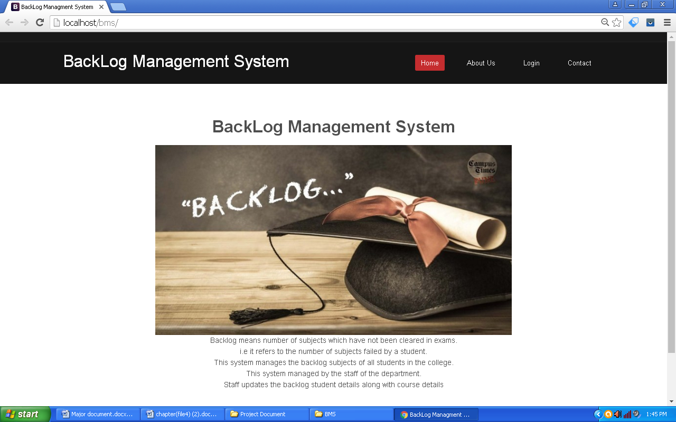

**Figure 5.1:** Home screen

**Description:** The above Fig shows home page of Backlog Management System.

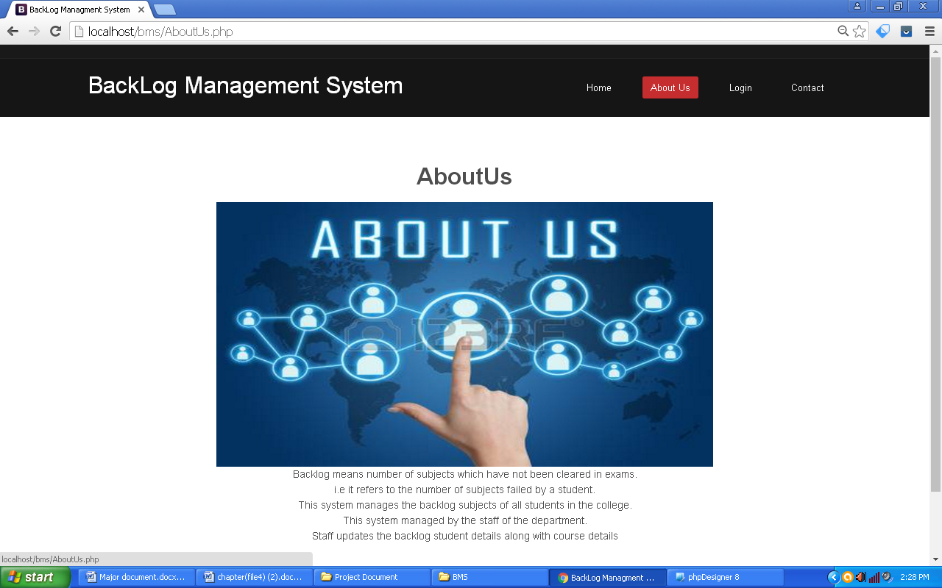

**Figure 5.2:** About Us

**Description:** The above Fig shows AboutUs page of Backlog Management System.

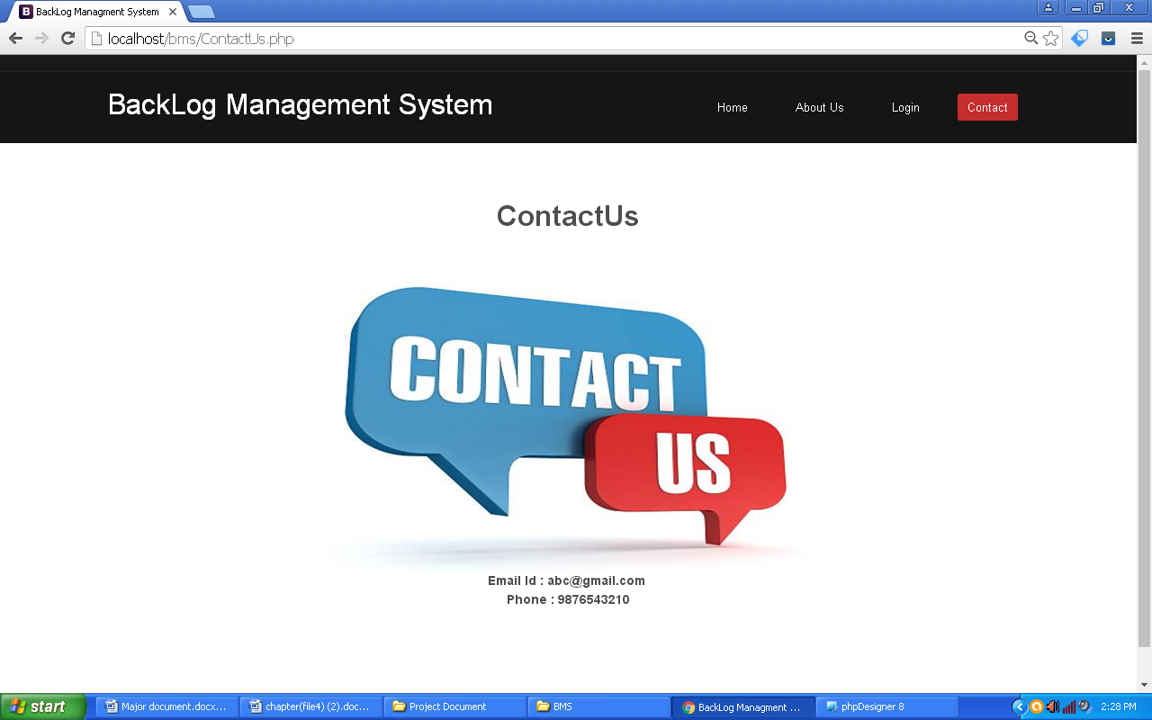

**Figure 5.3:** Contact Us

**Description:** The above Fig shows ContactUs page of Backlog Management System.

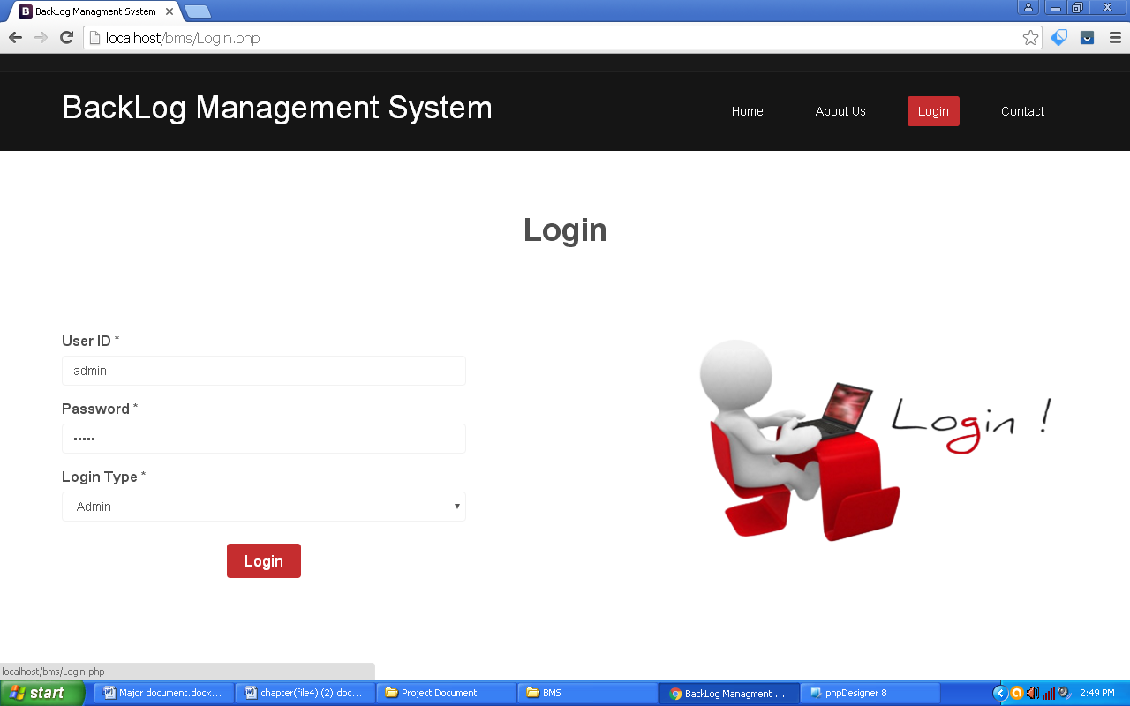

**Figure 5.4:** Login

**Description:** The above Fig shows Login page. Here Admin, Faculty and Student also used to Login the Backlog Management System.

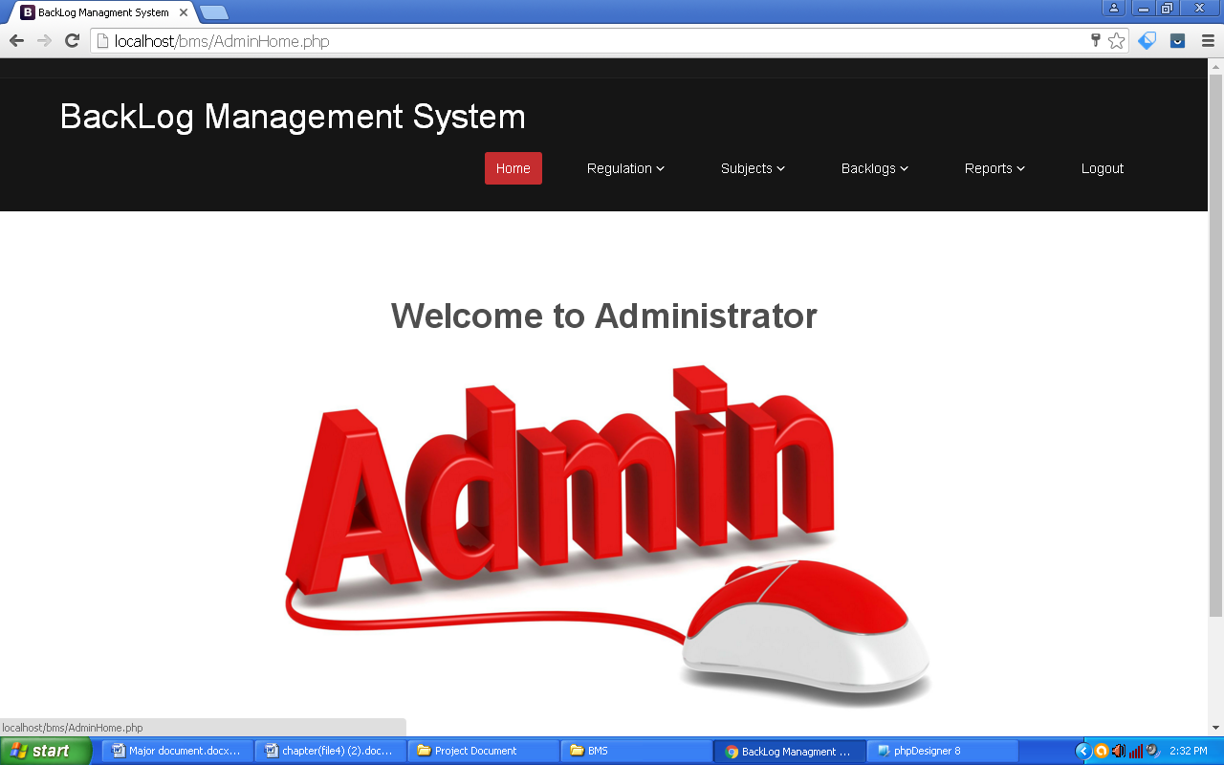

**Figure 5.5:** Admin Home page

**Description:** The above Fig shows Admin Home page of Backlog Management System.

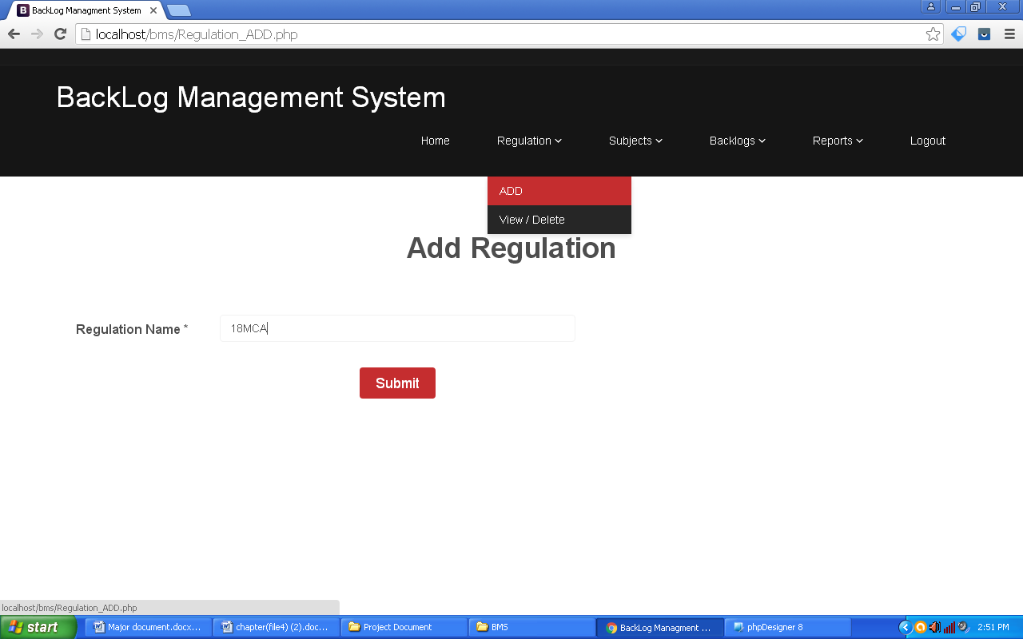

**Figure 5.6:** Regulation Add page

**Description:** The above Fig shows Regulation add page. Here we can add Regulation name.

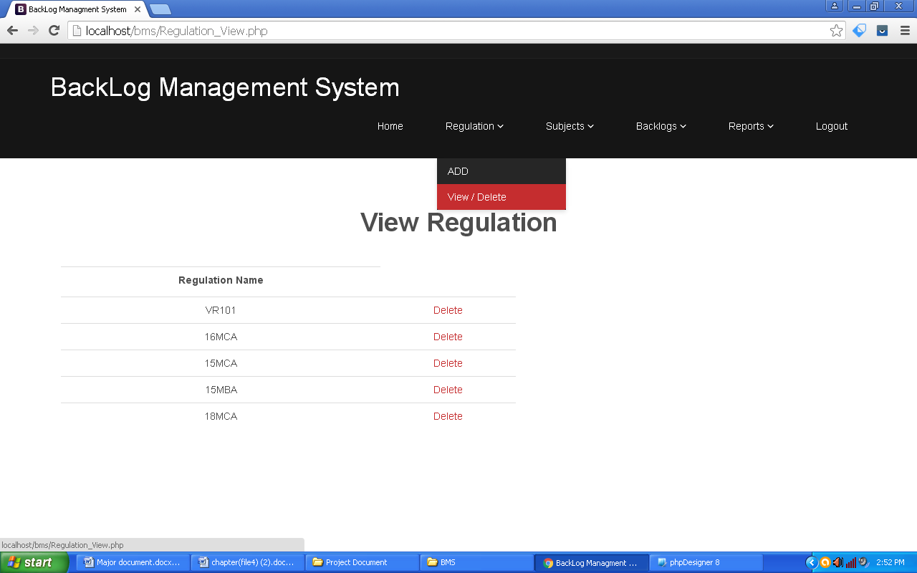

**Figure 5.7:** Regulation View page

**Description:** The above Fig shows Regulation View page. Here view all regulations added in previously.

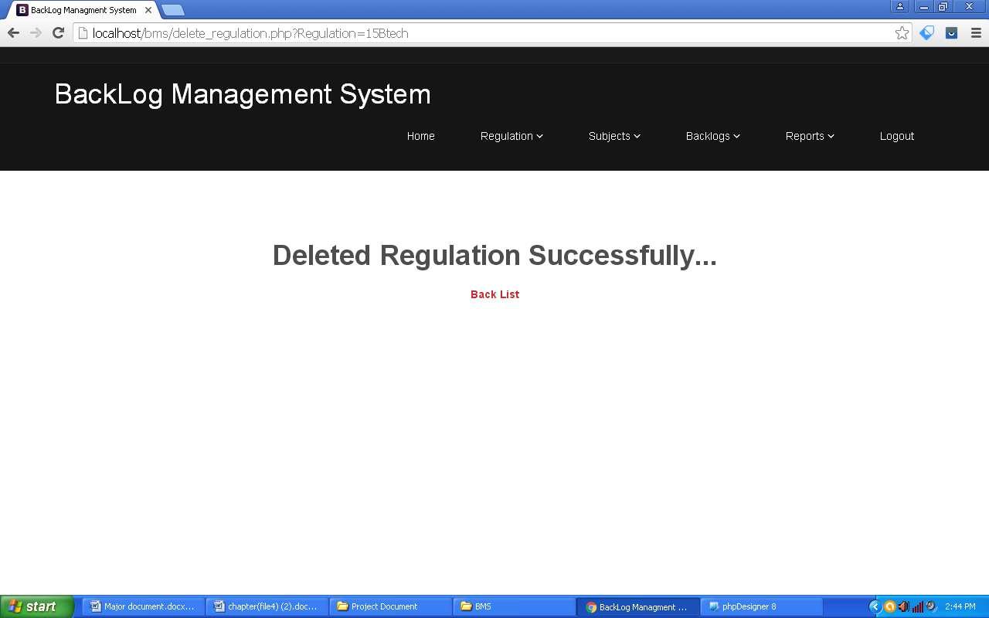

**Figure 5.8:** Regulation Delete page

**Description:** The above Fig shows Regulation Delete page. Here delete all regulations added in previously.

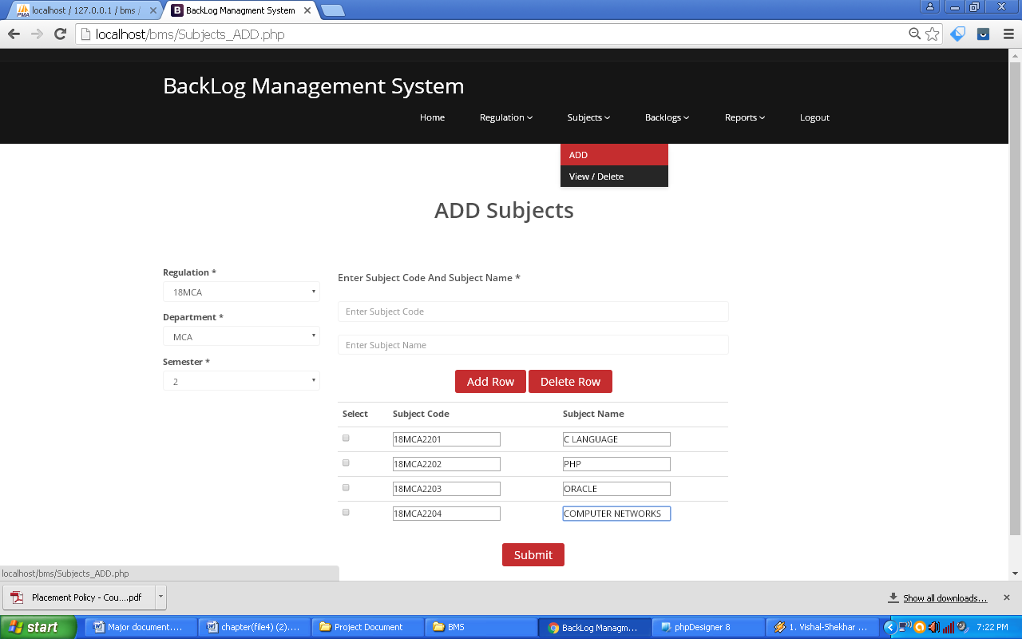

**Figure 5.9:** Subjects Add page

**Description:** The above Fig shows Subjects Add page. Here add more number of subjects at a time.

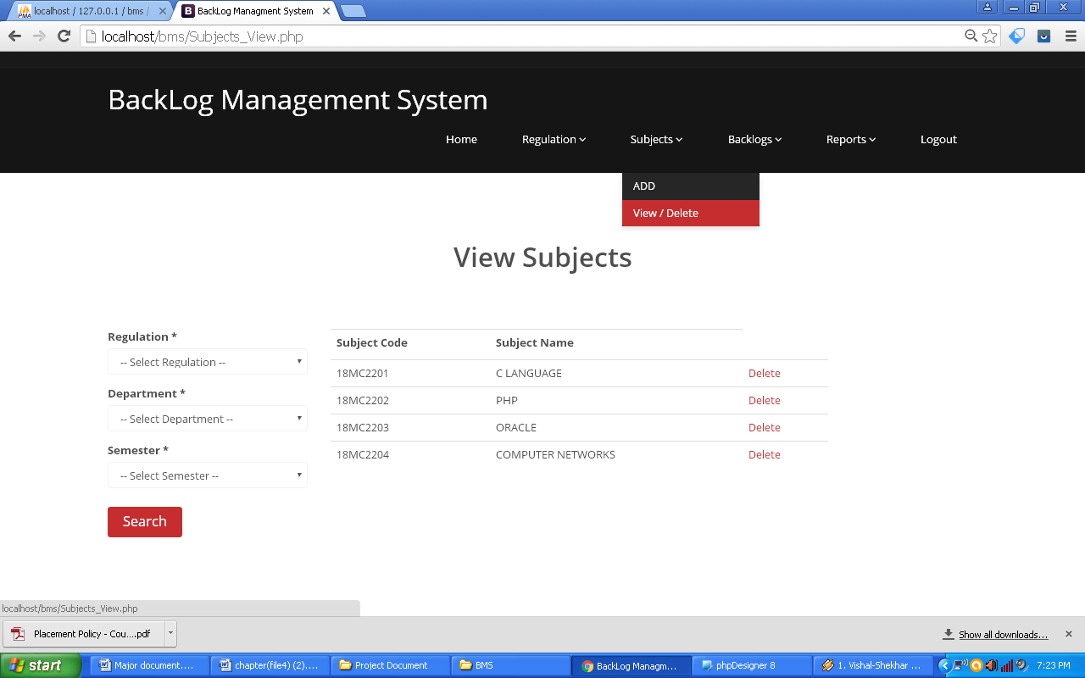

**Figure 5.10:** Subjects View page

**Description:** The above Fig shows Subjects View page. Here view all Subjects based on Regulation, Department and Semester wise added in previously.

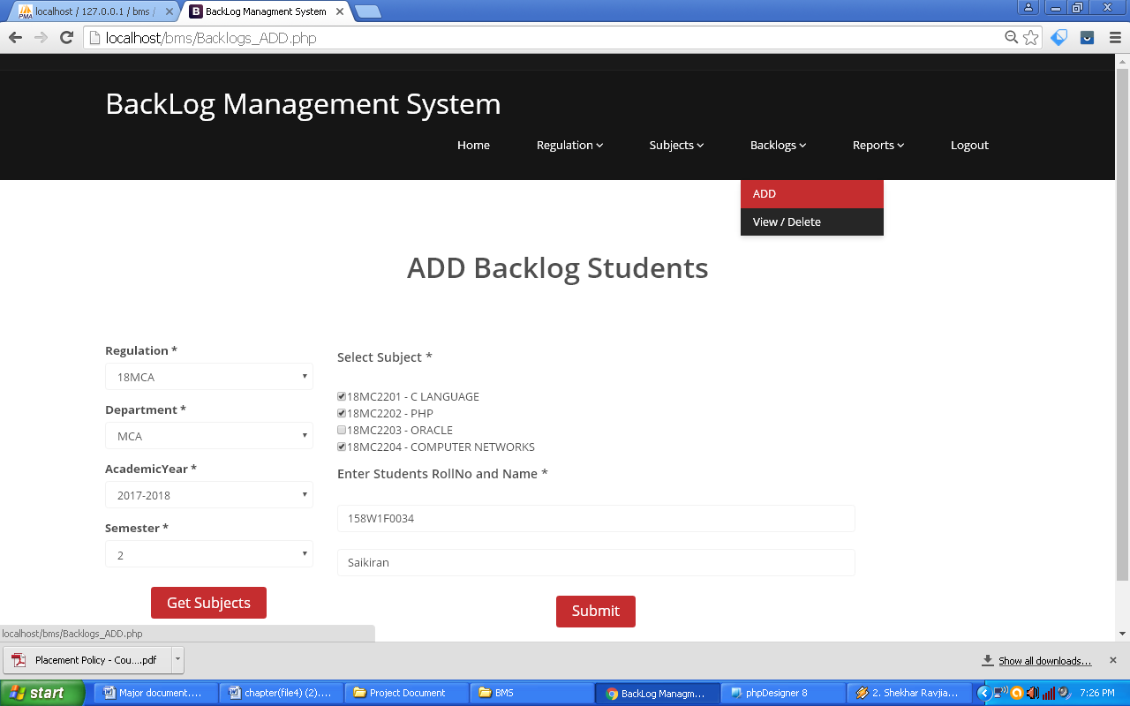

**Figure 5.11:** Backlog Students Add page

**Description:** The above Fig shows Backlogs Students Add page. Here add more number of Backlogs to a particular student.

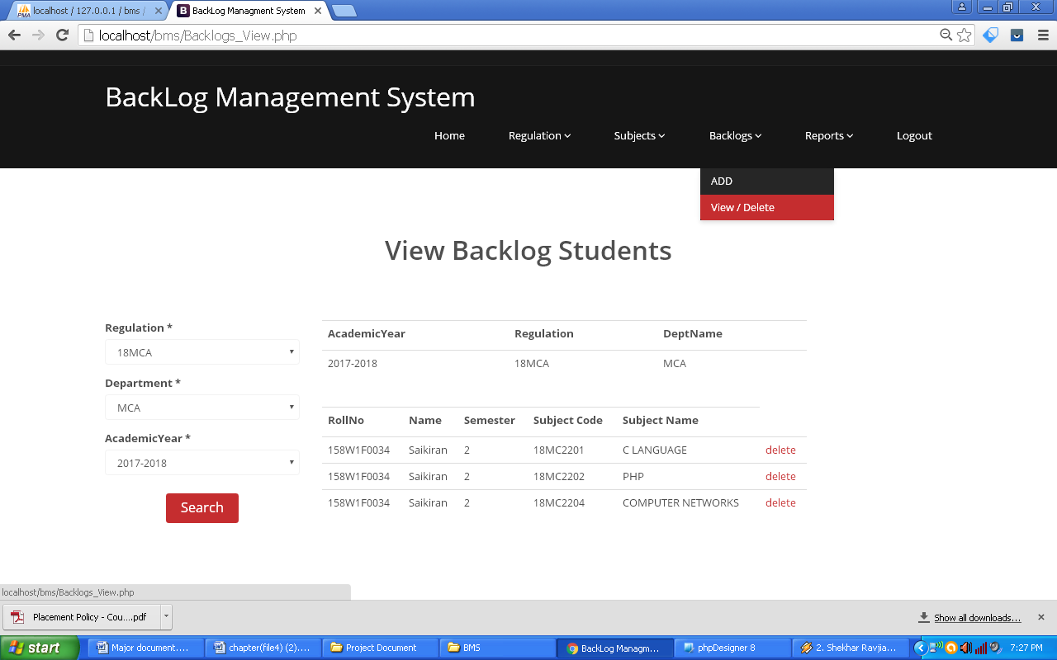

**Figure 5.12:** Backlogs Students View page

**Description:** The above Fig shows Backlog Students View page. Here view all Backlogs based on Regulation, Department and Academic year wise added in previously.

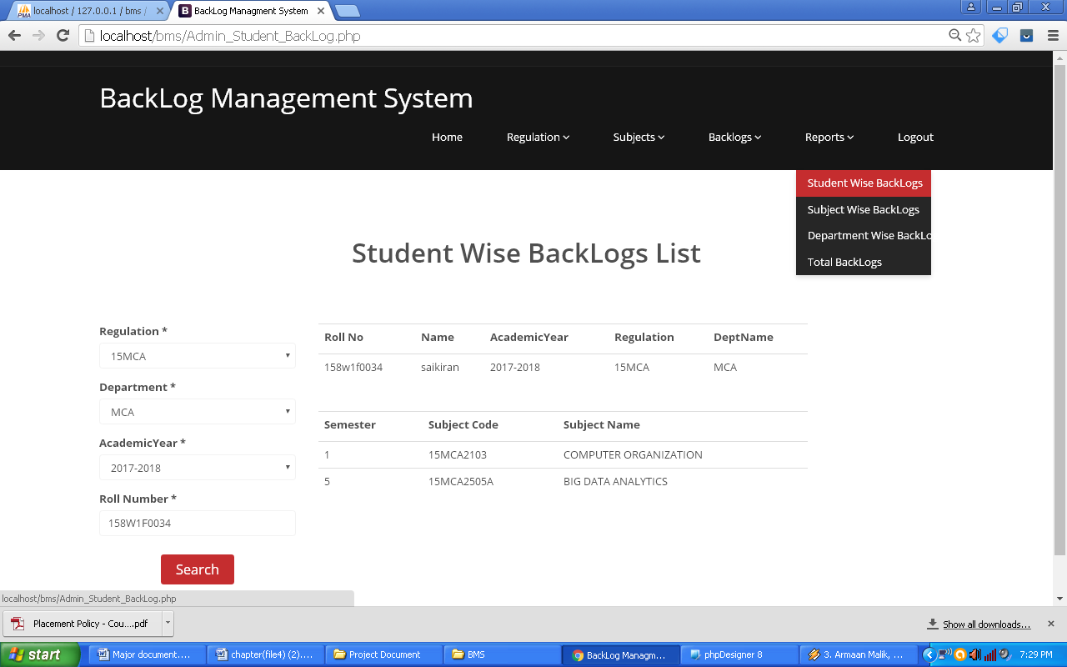

**Figure 5.13:** Student Wise Backlogs List

**Description:** The above Fig shows Student wise Backlog list. Here search student all backlogs.

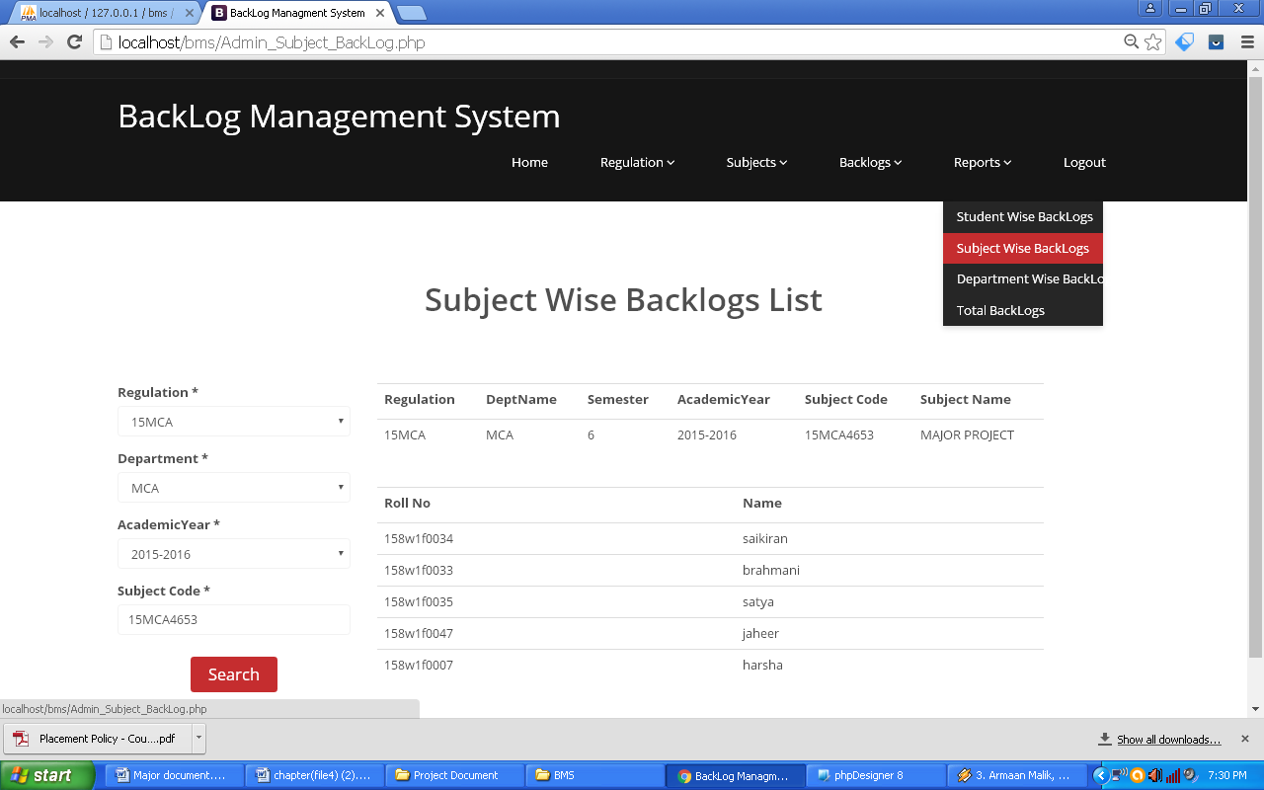

**Figure 5.14:** Subject Wise Backlogs List

**Description:** The above Fig shows Subject wise backlog list. Here search how many students have got Backlog in particular subject.

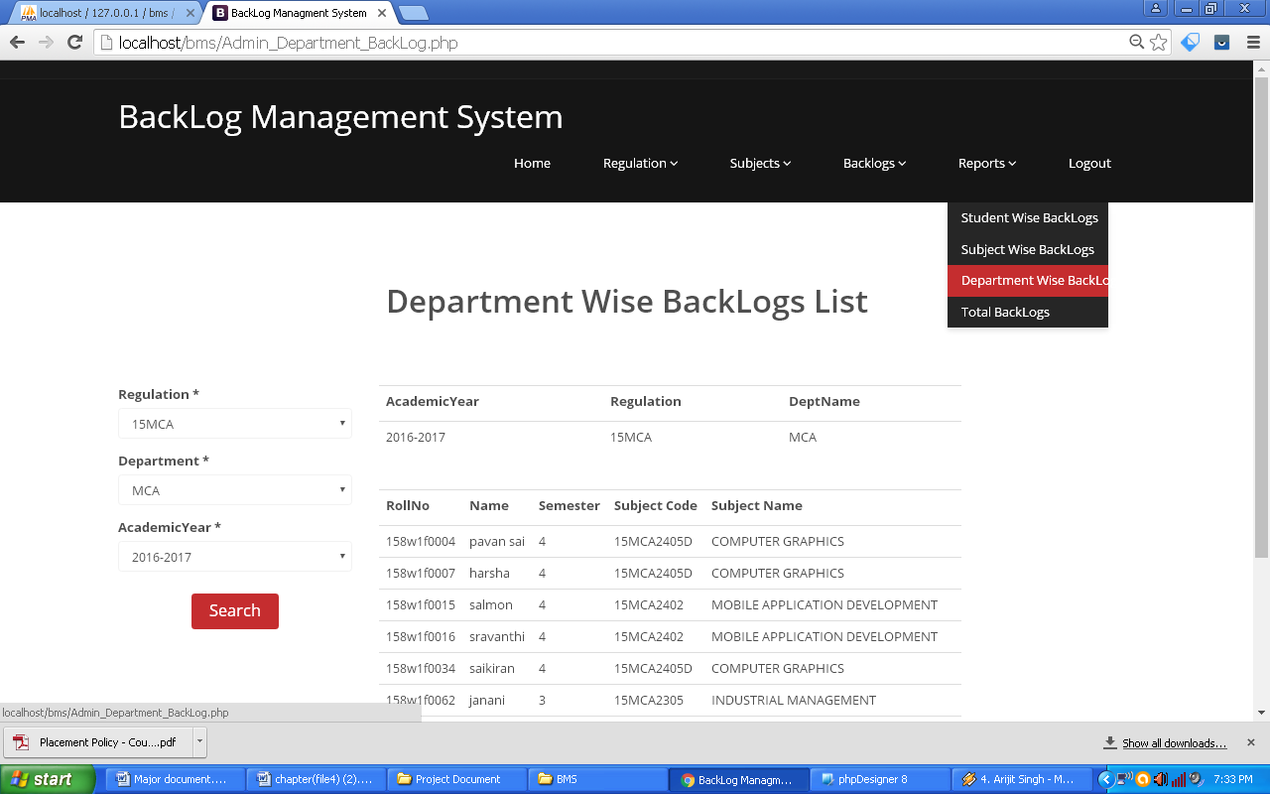

**Figure 5.15:** Department Wise Backlogs List

**Description:** The above Fig shows Department wise backlogs list. Here search all Backlogs based on the Department.

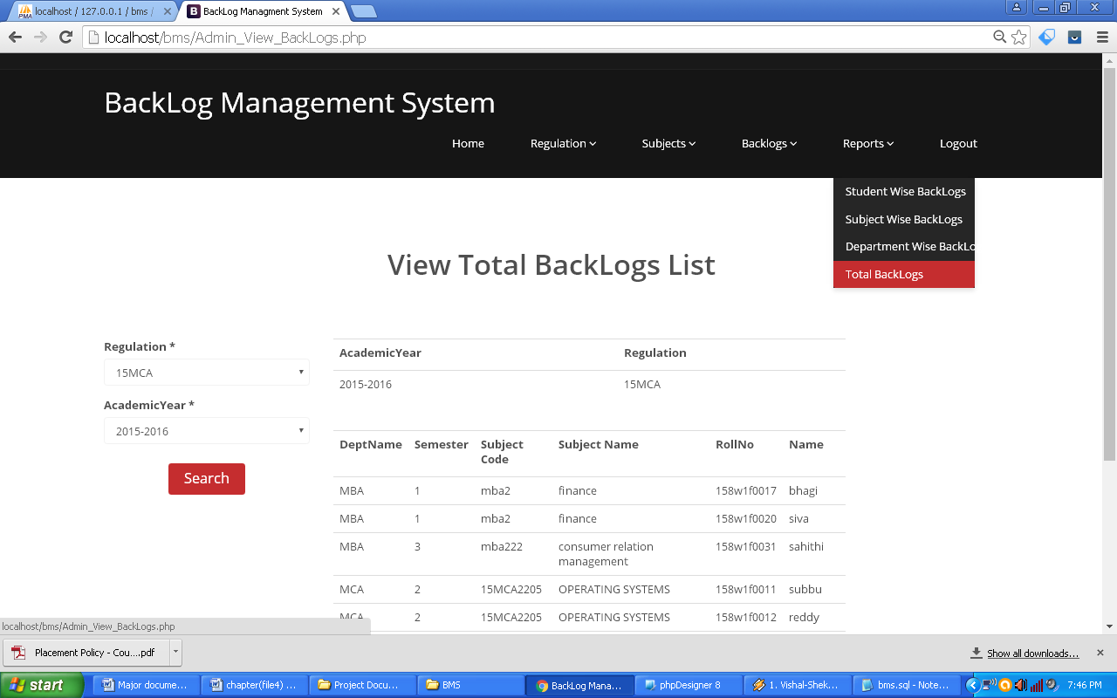

**Figure 5.16:** View Total Backlogs List

**Description:** The above Fig shows Total backlogs list. Here search all Backlogs.



**Figure 5.17:** Faculty Home page

**Description:** The above Fig shows Faculty Home page of Backlog Management System.

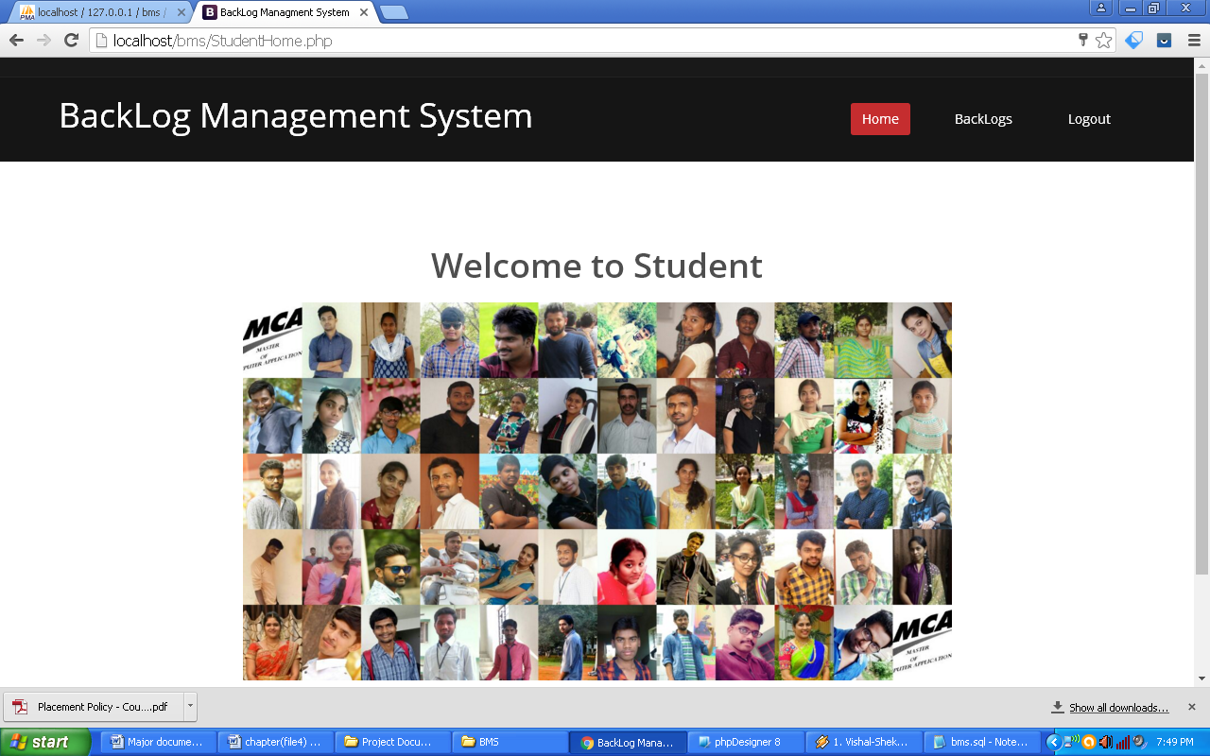

**Figure 5.18:** Student Home page

**Description:** The above Fig shows Student Home page of Backlog Management System.

**Chapter 6**

**Conclusion and Future Work**

The project “Backlog Management System” is a web portal which is useful to store the details of Backlogs. This system managed by the staff of the department. Staff updates the backlog student details along with course details for example Regulation, Department, Subject codes, Subject names etc. So that valuable student data/information can be stored for a longer period of time with easy accessing and manipulation can be done. This project is useful for students and educational institutions for getting the Backlogs in simple manner.

This system generates the reports of the students like subject wise, roll number wise & cumulative. Finallystaff can analyze which subjects are frequently failed by students. In this case faculty and students can check the Backlogs whenever they needed.

**Chapter 7**

**References**

**Text Books**

[1] Roger S Pressman, “Software Engineering–A Practitioner’s Approach”, Sixth Edition, TMH International.

[2] Michael Blaha, James Rumbaugh, “Object Oriented Modeling and Design with UML”, Second Edition, PHI.

[3] [PHP and MySQL for Dynamic Web Sites: Visual QuickPro Guide](http://www.amazon.com/exec/obidos/ASIN/0321186486/ref=nosim/forlagetadland00) by Larry Ullman. Peachpit Press. Paperback- 1 May, 2003.

**WEB Resources**

[1] <https://www.javatpoint.com/php-tutorial>

[2] <https://www.tutorialspoint.com/mysql>

[3] https://www.w3schools.com/html

[4] <https://www.w3schools.com/bootstrap/>

[5] https://www.codecademy.com/catalog/language/html-css